Q5: Gift Voucher Code Cracking Report
Author: Dominic Whye
Date: 13/02/2026

Context:
Ubuntu IP: 10.0.2.4
Open port on Ubuntu: 12419

a) Identifying the Open UDP Port
To identify the service port between 12345 and 12500, I used the nmap tool on the Kali Linux VM while the executable_server was running on the Ubuntu VM.
- Command Used:
nmap -sU -p 12345-12500 10.0.2.4
- Explanation:
The -sU flag is strictly required because the assignment specifies the service uses UDP (User Datagram Protocol). Standard TCP scans would fail to identify the open port as the service does not perform a TCP handshake.
- Result:
The open port identified was 12419

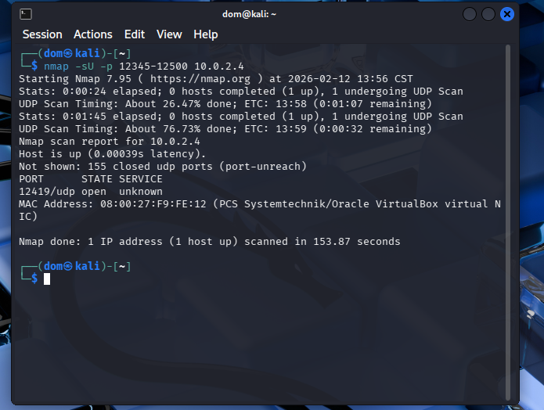

b) Obtaining the Gift Voucher Code
Using the identified port, I requested a voucher code by sending my 7-digit UOW student number (9891092) to the server using netcat.
- Command Used:
echo "9891092" | nc -u -w1 10.0.2.4 12419
- Explanation:
I used nc (netcat) with the -u flag to communicate over UDP. The -w1 flag sets a timeout to ensure the connection closes after receiving the response.
- Result:
The server returned the following MD5 Voucher Code:
0bda7b6ff1e51aa5cb4b3572a5be3164

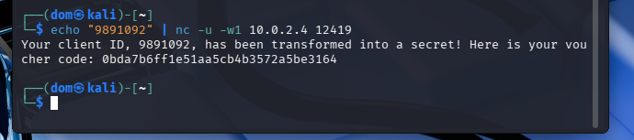

c) Cracking the MD5 Hash
The voucher code generation logic is $VoucherCode = MD5(A || ClientID || B)$. To find the unknown components (A and B), I used Hashcat with a mask attack.

1. Password Space Definition
- A (Prefix): Two lowercase alphabet characters (?l?l).
- ClientID: My static student number (9891092).
- B (Suffix): Two symbols (?s?s).

2. Cracking Process
I executed the following Hashcat command to brute-force the mask:
- Command:
hashcat -m 0 -a 3 0bda7b6ff1e51aa5cb4b3572a5be3164 "?l?l9891092?s?s"
Flag Breakdown:
- -m 0: Specifies the hash type as MD5.
- -a 3: Specifies the attack mode as Brute-force / Mask.
- ?l?l: The mask for the two random lowercase letters (Component A).
- 9891092: The static component (Component ID).
- ?s?s: The mask for the two random special symbols (Component B).

3. Final Results
Hashcat successfully cracked the hash in 17 seconds.
- The Recovered Plaintext: tj9891092<|
- Analysis of Components:
  - Component A (Prefix): tj
  - Component B (Suffix): <|
- Final Verified Construction:
The server generated the voucher by sandwiching my ID between tj and <|

